**Biodiversity and Color in the Amazon // Andrea Vale // April 2018**

**Introduction**

The Amazon rainforest has long been regarded as one of the most species-rich places on Earth. How it got to this point, however, has been the topic of much debate. Some researchers believe that the area underwent periodic cycles of flooding and subsequent retreat of saltwater from the Caribbean. This separated the land into islands of forest, which led to speciation. Existing marine species were also introduced and then cut off from the ocean. Other researchers believe that the rising of the Andes mountains created new habitats and weather patterns that allowed new species to evolve (Wade, 2015). Glaciers coming and going also form the basis of another widely known theory, tying together with the varying mountain habitats (Rull, 2011).

The point that is agreed on by all parties is that the Amazon rainforest is home to an incredibly biodiverse ecosystem. This can be seen in the dense forests and lush habitats full of over 40,000 plant species and hundreds, even thousands, of animal species. This includes around 1,300 types of birds and 100,000 types of invertebrates (Amazon wildlife). This is an immense collection of life.

**Goals and Significance**

Initially, before the trip, the goal was to compare biodiversity in Ohio to the rainforest through the use of photos and color analysis. However, there were many flaws to this (such as differences in season) and I changed my direction. Instead, the final product of this research aims to represent the biodiversity of the Amazon in an educational and visually appealing way. This can help to educate both students and the general public, helping to bring light to the Amazon and all it has to offer. Color can be used to illustrate the wide array of plants and animals, providing an overarching theme that ties all this different life together.

**Methods**

Throughout the course, we have been learning about biodiversity in the Amazon and I used this background knowledge to help direct my research. I also learned about different species while in the Amazon through both the guides and the instructors. This information, along with all of the animals I saw there, will help to clarify my research and provide relevant information to include in the final product. Also, the photos taken on the trip can be used in the final presentation of this project.

The final product is a Prezi presentation highlighting the biodiversity in the Amazon. I created a list of species, both ones we saw on the trip and others, to include in the presentation. I then conducted online research on these species and identified ways in which their unique colors and patterns enable them to thrive in the Amazon. I also found images of the different species to include. The presentation will be organized based on color in order to emphasize that theme and to create a product that is visually appealing to the audience.

**Results**

Throughout this research project, I discovered that depending on the group of animals, color is interpreted differently. For example, birds find fruits that have the highest contrast with the environment and this increases the reproductive success of plant species with the most visible fruit (Cazetta, Schaefer, & Galetti, 2007). Bees on the other hand can see light in the ultraviolet spectrum. Many plants that are pollinated by insects have a blue ring around their center of pollination to attract bees and encourage them to land where pollen may stick to them. The plant also may have stripes or dark spots that indicate where the insect should go. This increases pollination and reproductive success of plants that utilize this strategy (Morell, 2017). See Image 1 for example.

Animals also use color to increase survival and reproductive success. Members of the genus *Morpho* are butterflies that appear different shades of blue on the upper portion of their wings. However, the wings of the butterflies are not actually pigmented blue. They are made up of two layers of structures called scales that absorb all wavelengths of visible light except for blue. This creates the appearance of metallic blue wings (Giraldo & Stavenga, 2016). See Image 2. The under portion of their wings is various shades of brown, meaning they are camouflaged when their wings are closed. Reference Image 3 for a visual. Research has shown that male butterflies of this genus are territorial. The bright blue coloring helps them to establish their territory and also attract mates. There are multiple theories about how this coloring helps these butterflies avoid predation. One theory is that the irregular flashing pattern created by the light reflecting off the wings makes it hard for the predator to predict where the butterfly will be in order to attack. Another theory is that the butterflies will entice an attack by a bird, making the bird’s position known to it so it can then escape. This may increase the butterfly’s chance of survival and also frustrate birds so that they chase the blue butterflies less (Young, 1971).

Birds also use plumage color to communicate and adapt in a multitude of ways. Oftentimes, females are dully colored and males are brightly colored. This is because dull colors provide the female camouflage while watching over the nest, and bright colors allow males to attract mates and improve sexual preference for them. Females can identify potential mates quicker if they are brightly colored, and bolder colors are usually linked to healthier individuals. See Image 4 for the yellow-hooded blackbird, which exhibits sexual dimorphism. In this species, males will mate with multiple females and build nests for each of them (“Yellow-hooded”, 2012).

There are exceptions to this divide between genders, and in some species the females are bright while the males are dull. This involves a switch in roles as the females are then the ones defending territories and trying to attract a male mate, while males are tend to the nest. Evolution of color between sexes has also been researched. In eclectus parrots, which are not located in the Amazon but still provide a good example, males are a bright green, while females are a bright red and blue. The green coloring of the males allows them to blend in with foliage while they search for food for themselves, the females, and the chicks. The feathers also include some ultraviolet pigments that the other parrots can see better than other predatory birds. The red and blue feathers of the female signal the location of the bird at the nest hollow, typically to other females (Heinsohn, 2005).

**Limitations/Future Considerations**

Much of this data was collected through online research, post Brazil trip. The research, however, was supported in part by what was observed while in the Amazon and also information the guides provided.

I think that, if this project were to be expanded upon, it would be interesting to investigate how local people use the colors found in the Amazon in art, textiles, and production. This could include dyes made from plants or inspiration drawn from the wildlife. This could lead to increased exposure about the importance of nature to the local economy. It would also be interesting to continue others’ research on color and its importance with reproductive success and survival as this could be beneficial to conservation work.

**Conclusion**

This research shows that color is inherent to the reproductive success and survival of organisms, encompassing both plants and animals. Color can be used to draw attention to an organism or to hide it from preying eyes. Because color is so important and can be used in a wide range of ways, it makes it the perfect unifier to showcase diversity in nature.

It was amazing getting to see these brilliant hues in person while in Brazil. The final product intends to provide an accurate representation of at least a portion of the incredible diversity found in the Amazon rainforest.

**Reference Images**

Image 1.

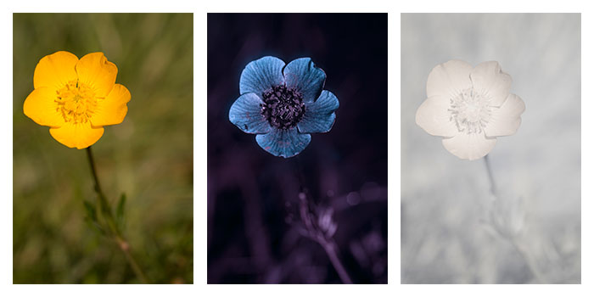

Kennard, D. (2015). Ranunculus bulbosus. Visible light on left. UV light on right. UV dark spot located centrally attracts insects to location of nectar and pollen. Image licensed CC-BY-SA 4.0. Accessed from Wikimedia Commons.

Image 2.

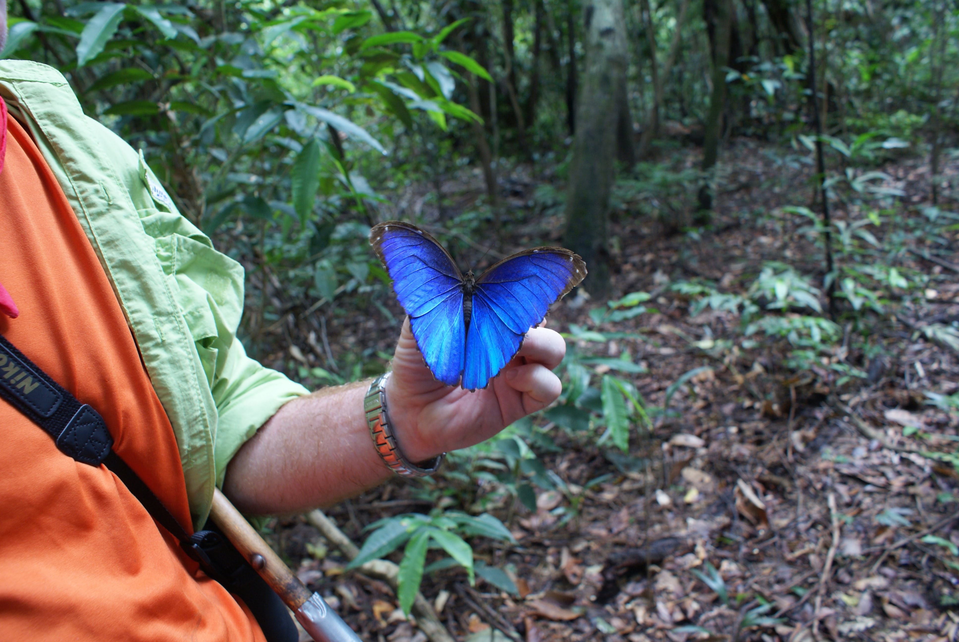

Tran, H. (2018). *Morpho menelaus*, blue morpho. Wings open.

Image 3.

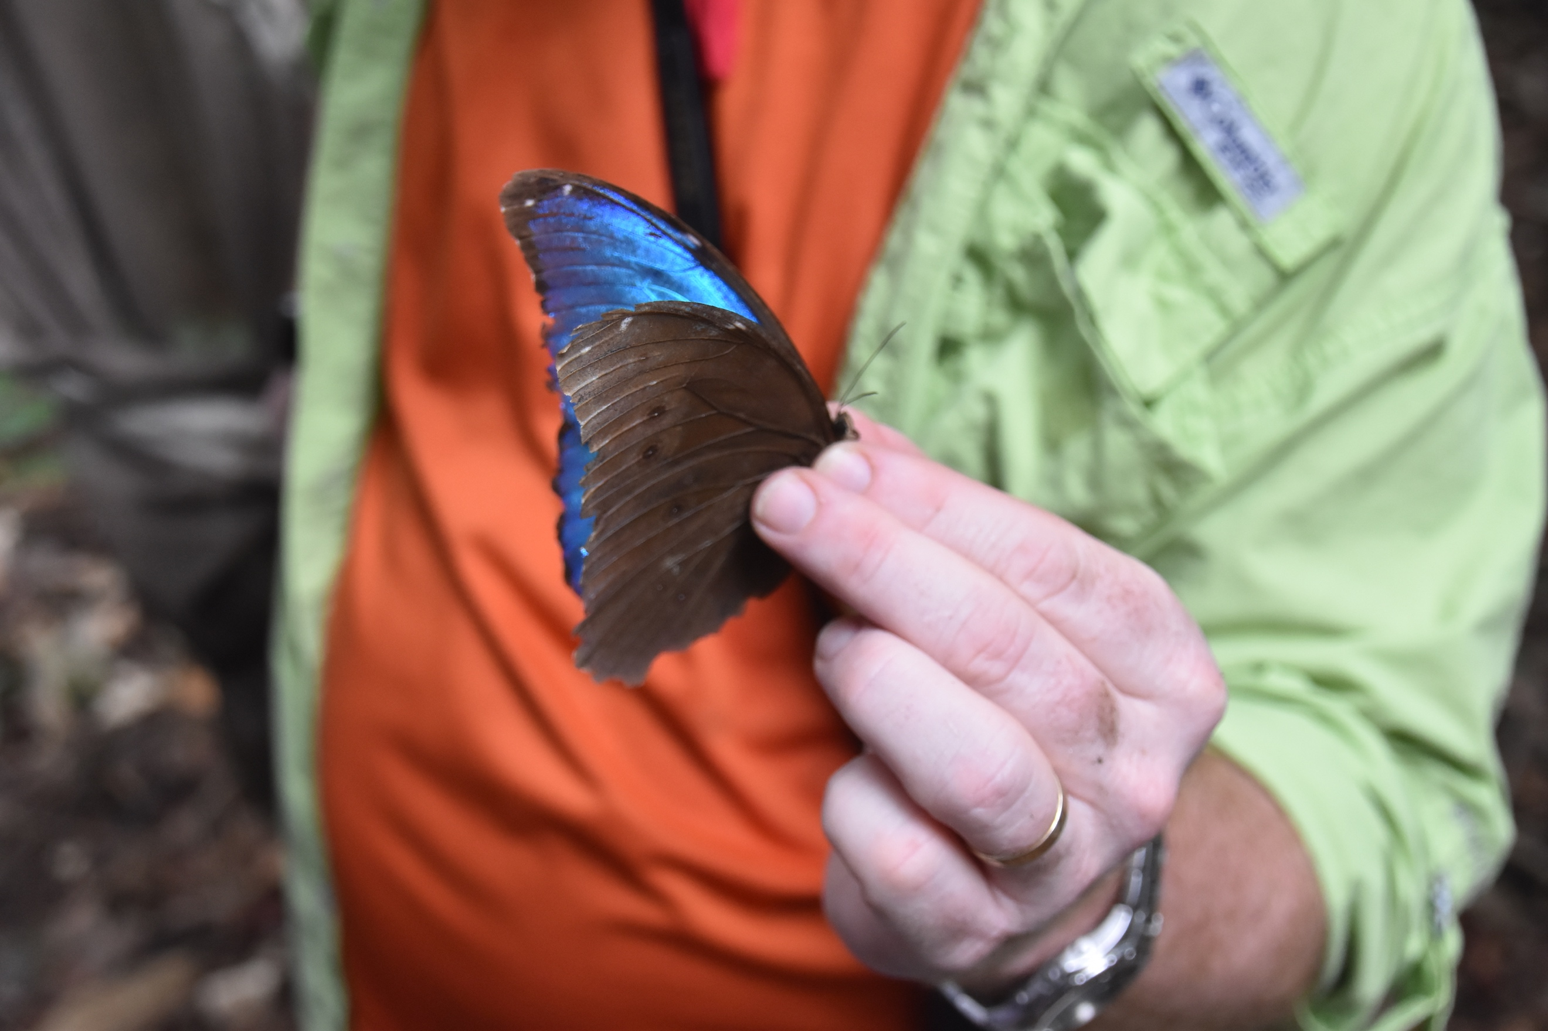

Phillips, Z. (2018). *Morpho Menelaus*,blue morpho. Wings partially closed. Side view.

Image 4.

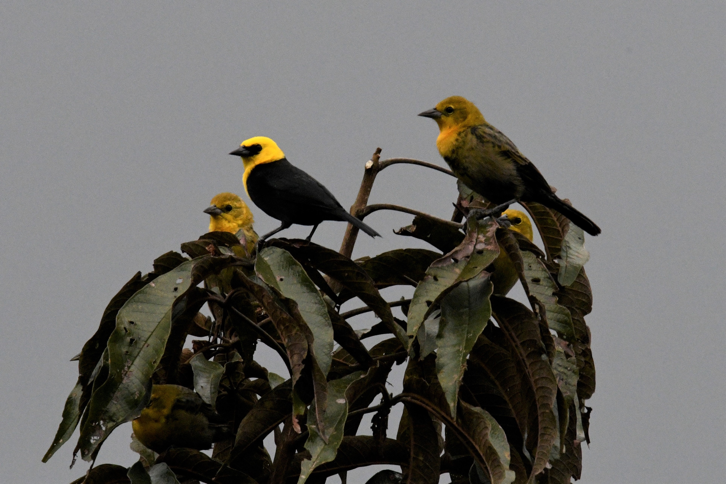

Howard, C. (2018). Yellow-hooded blackbirds. Male (top left) surrounded by three females.

**References**

Amazon wildlife. (n.d.). Retrieved April 01, 2018, from http://wwf.panda.org/what_we_do/where_we_work/amazon/about_the_amazon/wildlife_amazon/

Cazetta, E., Schaefer, H. M., & Galetti, M. (2007). Why are fruits colorful? The relative importance of achromatic and chromatic contrasts for detection by birds. doi:DOI 10.1007/s10682-007-9217-1

Giraldo, M. A., & Stavenga, D. G. (2016). Brilliant iridescence of Morphobutterfly wing scales is due to both a thin film lower lamina and a multilayered upper lamina. Journal of Comparative Physiology. A, Neuroethology, Sensory, Neural, and Behavioral Physiology, 202, 381–388. http://doi.org/10.1007/s00359-016-1084-1

Heinsohn, R. (2005, September 12). Why are male birds more colorful than female birds? Retrieved April 2, 2018, from https://www.scientificamerican.com/article/why-are-male-birds-more-c/?print=true

Morell, V. (2017). Flower petals have ‘blue halos’ to attract bees. *Science*. doi:doi:10.1126/science.aar2531

Rull, V. (2011). Neotropical biodiversity: Timing and potential drivers. *ScienceDirect,26*(10), 508-513. doi:https://doi.org/10.1016/j.tree.2011.05.011

Wade, L. (2015). How the Amazon became a crucible of life. *Science*. doi:doi:10.1126/science.aad4781

Yellow-hooded Blackbird Chrysomus icterocephalus. (2012). Retrieved April 2, 2018, from https://neotropical.birds.cornell.edu/Species-Account/nb/species/yehbla2/overview

Young, A.M. Oecologia (1971) 7: 209. https://doi.org/10.1007/BF00345212